# Interview questions:

1. Introduce | Working experience | hobby?
2. What is the testing model in your projects?
3. Do you know about the test plan? What does the test plan include?
4. What is the difference between white box, black box, and gray box testing? What testing type do you like most? Why?
5. Can you explain equivalence partitioning?
6. Have you ever worked with VM Ware tool? What did you do for?
   1. How do you do if you want to clone a virtual machine?
   2. If you had a mistake and you want to revert the system to the previous situation, how do you do?
7. Mobile testing?
8. Performance Testing?
9. Have you ever deployed or set up the testing environment?
10. Have you ever worked with SQL server? What did you do? Ask about Join, Store procedure, View?

**Working Experience:**

1. You reported an issue to developers but they rejects because they think it’s out of scope. What should you do?
2. How can you work on project if it’s missing the requirement to refer?
3. Do you willing to work OT if having the request from your manager?

**Automation:**

1. What is an XPath? How can you get the XPath of element?
2. Example for Log In page. What steps do you do with automation?
3. Describe about the hardest problem which you have ever met when working with your automation tool?
4. What are the common issues which you often meet?
5. What is your strategy to learn a new automation tool?
6. How to [handle frame in Web Driver](http://www.softwaretestinghelp.com/selenium-tutorial-18/)?
   * + By id => driver.switchTo().frame(“ID of the frame“);
     + By Tag Name =>driver.switchTo().frame(driver.findElements(By.tagName(“iframe”).get(0));
     + By Index => driver.switchTo().frame(0);

# Answers key

* 1. **SQL Exercise #2:**

UPDATE SALARIES SET sex = CASE sex WHEN 'm' THEN 'f' ELSE 'm' END

* 1. **Exercise #3: Find bugs**
     + The user Id field accepts special characters.
     + Confirm password field does not show content in encrypted mode.
     + There is no way user can reload the captcha.
     + Register button should be at bottom rather than on side.
     + Register button’s label has “r” instead of “R”.
     + There is no cancel button available if user wants to cancel the procedure..
     + There is no close button available if user wants to close the page.
     + The page title show wrong spelling of Registration.
     + Password selection guideline should be provided like the password should be alpha numeric or password strength factor should be present.
     + Page title should be New User Registration rather than New Registration.
     + Field length and labels should be same for the whole page / form.
     + The country field should by default show “Select” rather than selecting a value default*.*

# Test Case

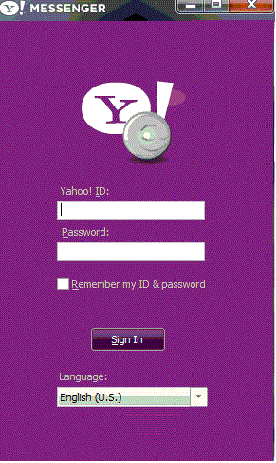

# Finding Bugs

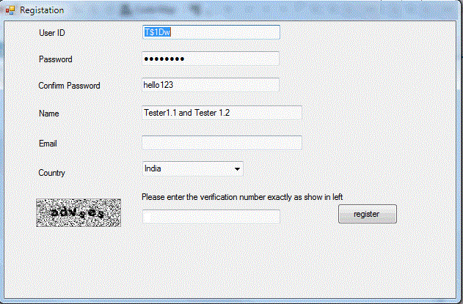

# SQL Exercise #1

**Customers**

|  |  |
| --- | --- |
| **CustomerID** | **Name** |
| 1 | John Nguyen |
| 2 | Bin Laden |
| 3 | Bill Clinton |
| 4 | Thomas Hardy |
| 5 | Ana Tran |
| 6 | Bob Carr |

**Orders**

|  |  |  |  |
| --- | --- | --- | --- |
| **OrderID** | **CustomerID** | **ProductName** | **DateProcessed** |
| 1 | 2 | Nuclear Bomb | ‘2002-12-01’ |
| 2 | 3 | Missile | ‘2000-03-02’ |
| 3 | 2 | Jet-1080 | ‘2003-08-03’ |
| 4 | 1 | Beers | ‘2001-05-12’ |
| 5 | 4 | Asian Food | ‘2002-10-04’ |
| 6 | 7 | Wine | ‘2002-03-08’ |
| 7 | 8 | Milk | ‘2002-05-02’ |

Query data using Select statement with the following Join

* + Inner Join
  + Left Outer Join
  + Right Outer Join
  + Full Outer Join
  + Cross Join

The result of the query must be displayed in the following format

|  |  |  |  |
| --- | --- | --- | --- |
| OrderID | CustomerName | ProductName | DateProcessed |

# SQL Exercise #2

Given a table SALARIES, such as the one below, that has m = male and f = female values. Swap all f and m values (i.e., change all f values to m and vice versa) with a single update query and no intermediate temp table.

|  |  |  |  |
| --- | --- | --- | --- |
| ID | Name | Sex | Salary |
| 1 | Emp01 | F | 800 |
| 2 | Emp02 | M | 1000 |
| 3 | Emp03 | F | 900 |
| 4 | Emp04 | M | 700 |

# Coding - Remove duplicate characters in a string